School/Department/Unit: School of Biological Sciences | Work activity:  Description -  Computation bioinformatics project identifying genetic associations & disassociations in the pangenome of Pseudomonas aeruginosa, to evaluate reasoning for inconsistencies in antimicrobial susceptibility test. This project will require no wet lab work and will be 100% computer based.  Venues:  SBS Creevey Lab
Assessment completed by: Katie Magill | Date completed: 23/10/2025 | Review Period: 1 year
Equipment: Computer

Activity  (task step) | Hazards | Who might  be harmed | Existing Control Measures  (What are you already doing?) | Severity  (1-5) | Likelihood  (1-4) | Risk Level (L,M,H, VH) | What further action is necessary | Final risk rating | Action by whom  & by when
Safe access, and movement while in the building/lab | Slips, trips and falls causing injury;  Striking fixed objects; | Staff and students | - Good level of housing keeping maintained  - Access routes kept clear of obstructions  - Tripping hazards eliminated  - Prompt cleaning up of spills  - Use of warning signs for wet floors  - No running | 2 | 2 | L | No further action required | L | Monitored by academic staff/supervisor in charge.
Fire and Emergency | Fire and smoke inhalation. | Staff and students | Academic staff in charge of this event will give students instructions in fire/emergency evacuation procedures and location of fire exits when they arrive on site | 3 | 2 | M | No further action required | M | Monitored by academic staff/supervisor in charge.
First Aid | Injury | Staff and students | If any of the students or academic guides become unwell a First Aider will be consulted.  First Aiders must wear PPE when attending to an injury/unwell individual. . | 3 | 2 | M | Academic staff in charge of and all attending the lab will find out details of First Aid staff on site, where the closest first aid box is and be aware of the appropriate numbers to call in case of an emergency. | L | Academic staff in charge of event will contact a member of the First Aid team
Electricity | Computers cause an electric shock.  Lab equipment can cause an electric shock/fire. | Staff and students | Computers regularly serviced and checked by Information Services.  Lab equipment maintained and tested as per university requirements. | 2 | 1 | L | Visual check of equipment prior to use (identification of defects in plugs, cables). Lab staff to supervise use of equipment. | L | Monitored by academic staff/supervisor in charge.
Workspace Management | Poor workspace setup can lead to trips and falls.  Overloaded electrical sockets pose a fire hazard | Staff and students | - Keep a clean and tidy Workspace  - Keep all computer wires under the desk/eliminate tripping hazards  - Do not overload electrical sockets | 2 | 2 | L | No further Action Needed | L | Monitored by academic staff/supervisor in charge
OVERALL RISK LEVEL = Low Risk Level

Severity | Probability |  |  |  |  | Risk Rating
 | Unlikely | Possible | Likely | Very Likely |  | Score | Risk Level
Minor | 1 | 2 | 3 | 4 |  | 1-5 | Low
Moderate | 2 | 4 | 6 | 8 |  | 6 | Medium
Serious | 3 | 6 | 9 | 12 |  | 8-10 | High
Very Serious | 4 | 8 | 12 | 16 |  | 12-20 | Very High
Extreme | 5 | 10 | 15 | 20

Signed.................................... 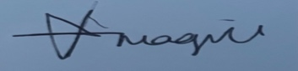........................................  (Student name: KATIE MAGILL )  Signed.......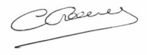.....................................................................  (Academic Supervisor name: Prof. Chris Creevey )  Signed............................................................................  (Environmental/ Safety Advisor:) | Date: 23/10/2025  Date:  Date:

I have read and understood the information contained in this Risk Assessment and I agree to adopt the control measures and precautions as stated above:

Name (Printed) | Signature | Date
KATIE MAGILL | 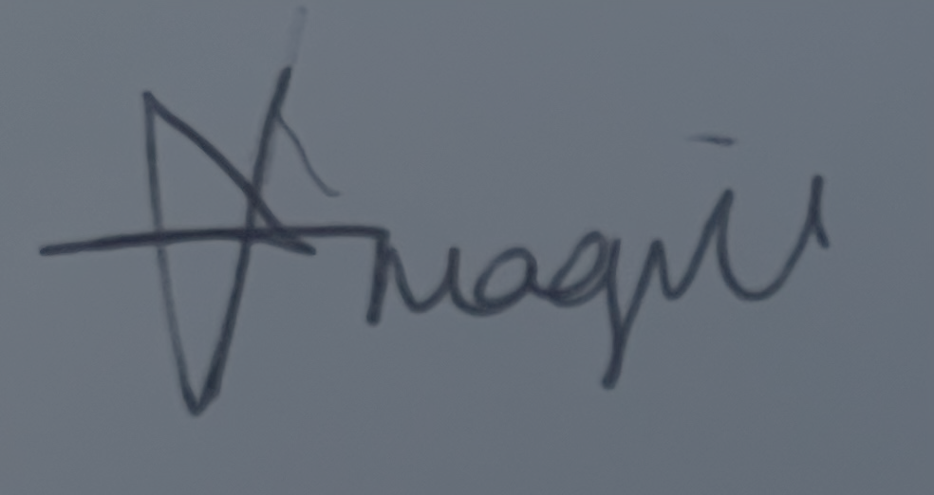 | 23/10/2025

This assessment should be reviewed at regular intervals and immediately if there is reason to suspect that it is no longer valid (for example after any accidents or incidents) or if there is a significant change in the work to which it relates.

